Five Stans
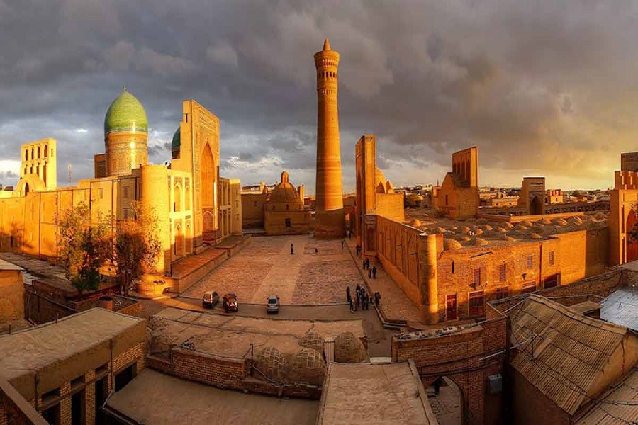Five Stans
The most detailed and prolonged 23-day tour, the Five Stans tour will take you along the route of the Silk Road and will introduce you the beautiful architecture of cities and the unforgettable beauty of nature. You will dive into the culture and history on the Five Stans tour by visiting Uzbekistan, Kyrgyzstan, Kazakhstan, Tajikistan and Turkmenistan and will learn what has been connecting nations of those countries for centuries.
Spend your first day in Tashkent, before leaving for the crafts centers of the Fergana Valley. Cross the border to Osh, Kyrgyzstan, a quaint little city known through the centuries as a trading center on the Silk Road. Ala-Archa National Park, in the mountains, and Issyk-Kul, a broad alpine lake, show off the natural beauty of Kyrgyzstan. Visit Almaty, Kazakhstan’s biggest city, before leaving early in the morning for Dushanbe. Dushanbe shows off the country’s modern side. Once back in Uzbekistan, get ready for the classic beauties of Samarkand, Bukhara, and Khiva. From Registan Square in the center of Samarkand to Ichan-Kala, the walled city in Khiva, these great cities are sure to leave an unforgettable impression with you. The final destination on this best Central Asia tour is Turkmenistan, with the broad Karakum Desert, the remains of ancient cities, and the modern city of Ashgabat.
This is the most comprehensive and best tour of Central Asia for those that want to explore every corner of this region. From the broad avenues of busy cities to the serene peace of natural sights, Central Asia’s best tours show off the diversity and beauty of these countries while also introducing you to the culture and traditions of each place.

Five Stans descriptions
Price Discount | 1 person – no discount  2 persons – 10% discount  3 persons – 20% discount  4 persons and up – 30% discount
Price Currency | USD
Destinations | Uzbekistan, Kyrgyzstan, Kazakhstan, Tajikistan, Turkmenistan
Offered | Any time
Deadline | Get confirmation 3 days before the departure date
Included | - All transfers: 1-2 pax on sedan type car, 3-6 pax on minivan/van, 8-13 pax by 20 seat bus;  - Accommodation based on double/twin room sharing, breakfasts included;  - Sightseeing tour program in each country with local guides (in Uzbekistan, different guides in each city);  - Entrance fees to sights as per itinerary;  - Economy class tickets for flights Osh-Bishkek, Bishkek-Almaty-Dushanbe, Ashgabat-Mary-Ashgabat;  - Ticket for train Samarkand-Bukhara;  - Visa support for Turkmenistan tourist visa;  - Dinners on days 5, 6, 7 and 20.
Excluded | - Tour leader to accompany the travellers for the whole period of the tour;  - Full board (lunches and dinners);  - Hotel charges for additional services;  - A tax of 2 USD per night in Turkmenistan, paid to the hotel upon check out;  - All costs associated with visas and Turkmenistan migration tax (14 USD);  - Visa support for Uzbekistan, Tajikistan, Kyrgyzstan and Kazakhstan tourist visas;  - International flight tickets before and after the tour;  - Tips are not included, but would be appreciated;  - Personal travel insurance.
Accommodation | N/A

Itinerary
Day 1: Tashkent – arrival
Arrive in Tashkent. Transfer from the airport to the hotel. Check in at noon. The Five Stans tour starts with sightseeing in the capital of Uzbekistan, the biggest city in Central Asia with a guide. Explore Old City part of Tashkent. There you will visit Khast-Imam Complex famous for keeping the holy book Quran of Caliph Uthman. Explore Chorsu Bazaar. Then take a ride on Tashkent Metro to city center to walk through Amir Timur Square, Independence Square and Applied Arts Museum. Enjoy free time in late afternoon. Overnight at the hotel.
Duration of sightseeing tour: 4-5 hours
Day 2: Tashkent – Kokand – Rishtan – Fergana
After breakfast drive to Fergana Valley (320 km drive till Fergana city). The steep road* which connects Fergana Valley with the rest of Uzbekistan runs via picturesque mountain pass Kamchik (2267 m above sea level). The first stop will be in the city of Kokand where you will visit the Khudoyar Khan Palace. Head to Rishtan town to visit a pottery workshop. Continue driving to Fergana city. Check in to the hotel in Fergana for overnight.
*Some parts of the road are under construction.
Duration of sightseeing tour: 4-5 hours
Day 3: Fergana – border point – Osh – Bishkek
After breakfast transfer to Uzbekistan-Kyrgyzstan border point Dustlik-Dostuk. Go through border formalities on both checkpoints. In Kyrgyzstan meet your local guide and driver and continue to Osh. Have a short city tour in Osh. As legends say, Osh was founded by King Solomon ages ago and had an important position on trading routes of the Great Silk Road. Visit Suleiman-Too (Solomon’s Mountain), National Museum of History and Archaeology, and Osh bazaar – this market is located at the same place as in the times of Great Silk Road. Late in the afternoon transfer to the local airport for flight to Bishkek. Upon arrival you will be transferred to the hotel for overnight.
Duration of sightseeing tour: 2 hours
Day 4: Bishkek – Ala-Archa – Bishkek
After breakfast transfer to the Ala-Archa National Park (40 km, 50 min) which attracts visitors with its beautiful mountain scenery and hiking trails. Fast flowing Ala-Archa River runs through the alpine gorge surrounded by snowy peaks with steep forested slopes. Enjoy free time or a hike in the park. In the afternoon return to Bishkek for city tour. Visit Oak Park, Ala-Too Square, Statue of Manas. See Philharmonic Hall and Victory Monument – bright examples of Soviet architecture. Overnight at the hotel.
Duration of sightseeing tour: 3-4 hours
Day 5: Bishkek – Issyk-Kul
After breakfast transfer to Issyk-Kul Lake (260 km, 4 h). On the way stop to see Burana Tower. This is a historical complex that marks the original site of Balasagun, a Karakhanid town. Continue driving to Issyk-Kul, the second largest mountain lake in the world (1600 m above sea level). Arrival at the lake, accommodation in a hotel at the North Coast of Issyk-Kul. Overnight at the hotel.
Day 6: Issyk-Kul – Karakol
After breakfast transfer to Karakol. On the way, a visit to an open-air museum of petroglyphs (V BC – VIII AD). Sightseeing tour on arrival at Karakol: visit to Russian Orthodox Church, the Dungan mosque which is built without using a single metal nail, and the museum of M.V. Prejvalsky.
Dinner at Uigur family. Kyrgyzstan is multiethnic country and today you will have a chance to taste Uigur food and get acquainted with their culture and traditions. Overnight at the hotel.
Day 7: Karakol – Jety-Oguz gorge – Bokonbaevo
Breakfast. Transfer to Jety-Oguz gorge (40 km), the picturesque gorge famous not only for its coniferous forest, flower clearings and interesting gorges for hiking, but also for red and sandy formations which are called «Seven Bulls» and «Broken Heart». Picnic. Transfer to Bokonbaevo Village. Dinner and overnight at a home stay.
Day 8: Bokonbaevo – Bishkek – Almaty
Breakfast. In the morning, transfer to Bishkek airport (300 km, 5 h). Check in for evening flight to Almaty (55 min). On arrival, you will be met by your Almaty driver and transferred to the hotel for overnight.
Day 9: Almaty
After breakfast your guide and driver will meet you at the hotel lobby to start the sightseeing tour in Almaty: visit Panfilov Park, Zenkov Cathedral, Central State Museum (closed on Tuesdays) and Republic Square. In the afternoon a short drive (25 km) will take you to Chimbulak. Here, visit the ski resort and ride the cable car to enjoy the amazing views of the snowy peaks of the Tian Shan Mountains. Our last stop of the day will be the Sunkar Falcon Farm, where you’ll enjoy a spectacular show with specially trained hawks – hunting with these magnificent birds is a distinguishing feature of the Kazakh way of life (closed on Mondays). Return to the hotel. Overnight at the hotel.
Day 10: Almaty – Charyn Canyon – Almaty
After breakfast leave Almaty and drive to Charyn Canyon (220 km, 3-4 h). This 154 m-long canyon is in eastern Kazakhstan, part of the Charyn National Park. In addition to unforgettable views of the enormous canyon with its multi-coloured tower formations, the National Park offers the opportunity to see an old ash-tree grove, the Castle Valley. The canyon’s beauty makes you forget the long drive from Almaty, and you will remember this highlight of Kazakh nature for a long time. After arriving at the canyon, take some time for a picnic and a rest. After that, walk along the canyon and enjoy the views. Late in the afternoon return to Almaty, overnight at the hotel.
Day 11: Almaty – Dushanbe
Breakfast. Check out from the hotel, flight to Dushanbe. Upon arrival, check in to the hotel. In the afternoon sightseeing Dushanbe: Mosque of Hoji Yakub, National Museum of Antiquities of Tajikistan, Gurminj Musical Instruments Museum. Overnight at the hotel.
Day 12: Dushanbe – Penjikent
After breakfast continue sightseeing Dushanbe: Ismail Somoni Monument, and Rudaki Park, trip to visit Hissar Fortress where you will see Madrasah Kuhna. In the afternoon depart Dushanbe and drive to Penjikent (270 km, 4-5 h). The mountain road goes via picturesque Anzob pass (3300 m above sea level). Arrive in Penjikent, check in to the hotel. Overnight at the hotel.
Duration of sightseeing tour: 3 hours
Day 13: Penjikent – Seven Lakes – Samarkand
After breakfast transfer to Seven Lakes (80 km, 1.5-2 h). The Seven Lakes are located in the west of Fann Mountains; each of them has its own colour which varies from calming turquoise to mesmerizing purple. At the last lake of Khoazorchashma you will enjoy a picnic. After lunch drive to Penjikent, a major Sogdian city in the 5th century destroyed by Arab conquerors in the 8th century. Sightseeing in Penjikent: Rudaki Museum, local Bazaar and mosque. Visit ancient Penjikent archaeological site located nearby.
Late in the afternoon return to the Jartepa border crossing, customs and passport control. On Uzbekistan side meet your driver and transfer to your hotel in Samarkand for overnight.
Day 14: Samarkand
After breakfast meet your guide and driver at the hotel lobby to start a city tour. Visit spectacular Registan Square, remains of Bibi Khanum Mosque, Siyob Bazaar, Ulugbek Observatory, Shakhi-Zinda Necropolis and Gur Emir Mausoleum – the mausoleum of Amir Timur. Overnight at the hotel.
Duration of sightseeing tour: 6-7 hours
Day 15: Samarkand
After breakfast continue sightseeing tour: visit Afrasiab Museum and the Tomb of Saint Daniel. Then drive to Konigil village to learn how Samarkand paper from mulberry is made in a traditional way. Free time in the afternoon. Overnight at the hotel.
Duration of sightseeing tour: 3-4 hours
Day 16: Samarkand – Bukhara
After breakfast check out from the hotel and transfer to the train station. Take the morning train to Bukhara. Arrive in Bukhara, transfer to the hotel. Enjoy a walking sightseeing tour with a guide in Old City. Visit Lyabi-Khauz Ensemble, Magoki-Attori Mosque, Chor-Minor Madrasah, trade domes, Kalyan Minaret, Kalyan Mosque and Miri-Arab Madrasah, Ulugbek and Abdulazizkhan madrasahs, Ark Fortress, Bolo-Khauz Mosque, Ismail Samani and Chashma-Ayub mausoleums. Overnight at the hotel.
Duration of sightseeing tour: 6-7 hours
Day 17: Bukhara
After breakfast start the second day in this holy city with a visit to Sitorai Mokhi-Khosa – the summer residence of Bukhara’s last emir, unique site combining Oriental and Russian architecture. Continue to the Mausoleum of Bakhouddin Naqshbandi and Chor-Bakr Necropolis. Enjoy free time in the afternoon. Overnight at the hotel.
Duration of sightseeing tour: 3-4 hours
Day 18: Bukhara – Khiva
After brekafast depart Bukhara and drive to Khiva (480 km, 7-8 h*). The Great Silk Road once routed through Bukhara and Khiva ran through the Kyzylkum Desert, today you will pass the same route**. Stop en-route to enjoy views of the desert and the Amudarya River. Arrive in Khiva late in the afternoon, check in to the hotel. Time for rest. Overnight at the hotel.
Day 19: Khiva
Breakfast. Today you will visit Ichan-Kala Fortress, a UNESCO World Heritage site. The tour features visits to Mukhammad Amin Khan Madrasah, Mukhammad Rahimkhan Madrasah, Kalta Minor, Juma Mosque, Toshkhovli Palace, Pakhlavan Makhmud Mausoleum. Try yourself at climbing Islom Khodja Minaret, the highest minaret in Uzbekistan. Enjoy breathtaking panoramic views of Old Khiva in Kunya-Ark. Free time in the afternoon. Overnight at the hotel.
Duration of sightseeing tour: 5 hours
Day 20: Khiva – Darvaza
Breakfast. Free time in the first half of the day. Check out from the hotel at noon, drive to Turkmenistan border point Shavat-Dashoguz (60 km, 1 h). Go through border formalities on both checkpoints. Cross the 1.5 km neutral zone (transportation may not be available). Meet your Turkmenistan guide and drive to Darvaza Gas Crater located in the middle of Karakum Desert (270 km, 4 h). Set up the camp. Enjoy a delicious fire-cooked meal for dinner near the burning gas crater. Overnight in tents.
Note: At Darvaza camp you will be provided with sleeping bags, pillows, and 1- or 2-person tents. There is also an option to share a yurt with 3-5 other group members. In both cases, toilets and basic washing facilities are outside.
Day 21: Darvaza – Ashgabat
After breakfast depart the camp site and drive to Ashgabat. Arrive in Ashgabat check in to the hotel. Sightseeing Ashgabat in the afternoon. During the city tour you will explore an archaeological site of Old Nissa (included in UNESCO World Heritage list) and Spiritual Mosque, one of the biggest mosques in Central Asia. You will visit the National Museum of History, the Monument of Neutrality, Ertugrul Gazi Mosque and newly built Independence Park. Overnight at the hotel.
Duration of sightseeing tour: 6 hours
Day 22: Ashgabat – Mary – Merv – Mary – Ashgabat
Breakfast. Transfer to the airport to take a morning flight to Mary (370 km, 40 min). Upon arrival drive to Merv (40 km, 30 min), an ancient city that was a major center of international trade and crafts located on the Silk Road. Discover historical park that includes Sultan Sanjar Mausoleum, Large and Small Gyz Gala, Erk Gala, Gyaur Gala, Keshk Fortress, and others. Return to Mary Airport to get the flight back to Ashgabat. Transfer to the hotel for overnight.
Duration of sightseeing tour: 4-5 hours
Day 23: Ashgabat – departure
Transfer to the airport. End of the tour service.

