Uzbekistan-Tajikistan Group Tour
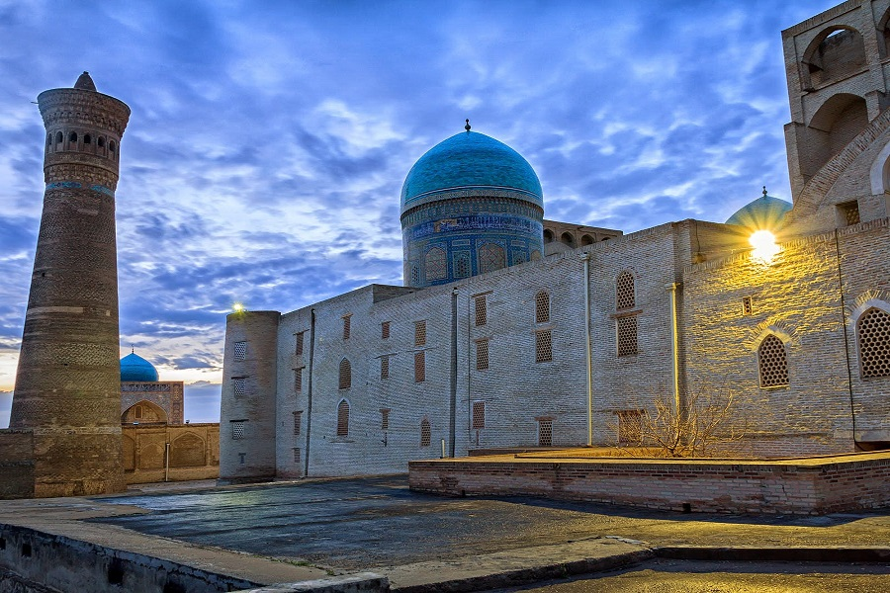Uzbekistan-Tajikistan Group Tour
Explore this world of ethereal beauty and fairy tales with the Uzbekistan-Tajikistan Group Tour. Take a walk through local bazaars to feel the spirit of the Silk Road, visit the ancient cities of Samarkand, Bukhara, and Penjikent to discover the architectural beauty of the Middle Ages, and revel in the grandeur of nature at Iskanderkul Lake. Travel with like-minded tourists through these two great countries at a shared cost, without sacrifice on experiences or comfort.

Uzbekistan-Tajikistan Group Tour descriptions
Price Currency | USD
Destinations | Kazakhstan, Kyrgyzstan, Uzbekistan, Turkmenistan, Tajikistan
Offered | Any time
Deadline | Get confirmation 3 days before the departure date
Included | - Accommodation based on double room sharing throughout the tour, breakfasts included;  - Transportation throughout the tour, including airports/train stations pick up and drop offs;  - Sightseeing with local English speaking guide in each city;  - Entrance tickets to the sights as per itinerary;  - Economy class tickets for flights Tashkent-Urgench, Urgench-Bukhara;  - Economy class ticket for train Bukhara-Samarkand (on rare occasions when the high-speed train is unavailable, we will replace this with the most-comfortable class of regular train);  - Dinner with folklore show program at Nadir Divan-begi Madrasah in Bukhara, farewell lunch in Samarkand;  - Visa support letter for Uzbekistan visa;  - Visa support letter for Tajikistan tourist visa;  - Full board (lunches and dinners) in Tajikistan;  - English speaking tour leader from Advantour to accompany the group of 8 persons and more;  - English speaking local tour leader in Tajikistan.
Excluded | - Tour leader to accompany travellers for the whole period of the tour in Uzbekistan for groups with less than 8 persons;  - Full board (lunches and dinners) in Uzbekistan;  - Hotel charges for additional services;  - Consular fees for Uzbekistan and Tajikistan tourist visas;  - Camera fees, charged separately by museums;  - International flight tickets before and after the tour;  - Travel insurance.
Accommodation | N/A

Itinerary
Day 1, Fr: Tashkent – arrival
Arrival in Tashkent. Meet your driver and transfer to the hotel. Check in at noon. Free day.
Day 2, Sa: Tashkent – Urgench – Khiva
After breakfast start guided sightseeing tour in the capital of Uzbekistan, the biggest city in Central Asia. You will start with exploring the Old City. Visit Khast-Imam Complex, where the world famous Quran, holy book that belonged to Caliph Uthman, has been preserved. The complex consists of Barak-Khan Madrasah, Tillya Sheykh Mosque, Saint Abu Bakr Kaffal Shashi Mausoleum and the Islamic Institute of Imam al-Bukhari. Continue to Chorsu Bazaar. Then take a ride on Tashkent Metro to the city center to walk through Amir Timur Square, Independence Square and visit Applied Arts Museum.
Transfer to domestic airport, evening flight to Urgench departing at 19:00 (1093 km, 1 h 40 min). Arrival in Urgench at 21:20, transfer to the hotel in Khiva (30 km, 35 min).
Duration of sightseeing tour: 4-5 hours
Day 3, Su: Khiva – Urgench – Bukhara
After breakfast sightseeing tour in Khiva. Visit Itchan-Kala Fortress, a UNESCO World Heritage site. In Itchan-Kala Fortress visit Kunya-Ark, Sayeed Alauddin Mausoleum, Arab-Mukhamadkhan Madrasah, Oq-Masjid Mosque, Madrasah of Hodjan Berdi-biya, Shirgazikhan Madrasah, Abdullakhan Madrasah, Juma Mosque, Allakulikhan Madrasah, Tosh-Khovli Palace, Pakhlavan Makhmud Mausoleum, Minaret of Islom-Khoja. At 19:00 transfer to domestic airport flight to Bukhara at 21:00 arriving in Bukhara at 22:00. Arrival in Bukhara, transfer to the hotel.
Duration of sightseeing tour: 4-5 hours
Day 4, Mo: Bukhara
After breakfast start walking sightseeing tour in Bukhara.
Visit Lyabi Hauz Ensemble, Magoki-Attori Mosque, Chor-Minor Madrasah, trade domes, Kalyan Minaret, Kalyan Mosque and Miri-Arab Madrasah, Ulugbek and Abdulazizkhan madrasahs, Ark Fortress, Bolo-Khauz Mosque, Ismail Samani and Chashma-Ayub mausoleums. Dinner and a National Show at Nadir Divan-begi Madrasah.
Duration of sightseeing tour: 6-7 hours
Day 5, Tu: Bukhara – Samarkand
Breakfast. Start the second day with a visit to Sitorai Mokhi-Khosa – the summer residence of Bukhara’s last emir, unique site combining Oriental and Russian architecture. Continue to the Mausoleum of Bakhouddin Naqshbandi and Chor-Bakr Necropolis. In the afternoon take the high-speed Afrosiyob train 15:52-17:20 or overland transfer. Arrive in Samarkand, check in to the hotel.
Duration of sightseeing tour: 3-4 hours
Day 6, We: Samarkand
After breakfast, Samarkand sightseeing tour. Visit spectacular Registan Square, Gur Emir Mausoleum – the mausoleum of Amir Timur, remains of Bibi Khanum Mosque, Siab Bazaar, Ulugbek Observatory. Free time in the afternoon.
Duration of sightseeing tour: 6-7 hours
Day 7, Th: Samarkand
Breakfast. Continue sightseeing tour in Samarkand. You will visit Shakhi-Zinda Necropolis, Afrasiab Museum and the Tomb of Saint Daniel. Then drive to Konigil village to explore traditional way of making Samarkand paper from mulberry. Farewell lunch in Samarkand. Free time in the afternoon. Overnight at the hotel.
Duration of sightseeing tour: 4-5 hours
Day 8, Fr: Samarkand – Seven lakes – Penjikent
Early morning transfer to Uzbekistan-Tajikistan border Jartepa (50 km, 1 h). Customs and passport control on both sides, cross the border, meet Tajik local guide and driver to Seven Lakes (80 km, 1.5-2h.). Haf Kul - seven lakes of different colors in mountains of Tajikistan: 1. Mijgon, 2. Soya, 3. Hushyor, 4. Nophin lakes (2139m.a.l), Khurdak, 6.Marguzor, 7.Hazorchashma lakes (2400m a.s.l.). Picnic at the lake.
After lunch drive to Penjikent. Sightseeing in Penjikent: Rudaki Museum, as Penjikent is a birthplace of Abu Abdallah Rudaki, considered by many to be the father of Persian Poetry. Visit the ancient Penjikent ruins of old Sogdian town founded in the 5th century and abandoned in the 8th century by Arabs. Foundations of houses, a citadel with a couple of Zoroastrian fire temples and city bazaar are visible in the excavated ruins. Overnight at the hotel.
Meals: breakfast, lunch, dinner
Day 9, Sa: Penjikent – Iskanderkul – Dushanbe
Drive to Dushanbe via Iskanderkul Lake. According to the legend, the Lake Iskanderkul was named after Alexander the Great, known as Iskander in the East. People say that Alexander the Great's path to India passed by this lake. Lunch at the traditional homestay "Dilovar". After, you will stroll around the lake, explore five springs and Zmeinoe (Snake) Lake, walk to 38 m high waterfall that local people compare to Niagara and call Fanskaya Niagara (Niagara of Fan). Drive to Dushanbe. Overnight at the hotel.
Meals: breakfast, lunch, dinner
Day 10, Su: Dushanbe
Start sightseeing in the capital of Tajikistan. Visit the Botanical garden, a very beautiful garden with many old trees, and a favorite place of Tajik people, National Museum of Antiquities of Tajikistan (closed on Mondays) that includes exhibits on history, natural history and art (Buddha in Nirvana is one of the most valuable exhibits of the museum), Ismail Somoni Monument, the Building of National Spirit, Rudaki Prospect and the Main Mosque of Dushanbe. Overnight at the hotel.
Duration of sightseeing tour: 5-6 hours
Meals: breakfast, lunch, dinner
Day 11, Mo: Dushanbe – departure
Check-out from the hotel till noon. Transfer to Dushanbe Airport. End of the tour.

